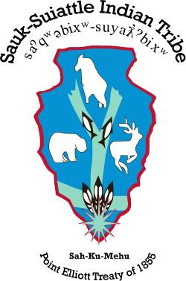 Resolution Number: ___/__/2019
Tribal Council

5318 Chief Brown Lane
Darrington, Washington 98241-9420

(360) 436-0131
Fax (360) 436-1511
(Title)
BE IT RESOLVED BY THE TRIBAL COUNCIL OF THE SAUK-SUIATTLE INDIAN TRIBE
WHEREAS, the Sauk-Suiattle Tribal Council (the “Tribal Council”) is the governing body of the Sauk-Suiattle Indian Tribe (the “Tribe”) of authority of the Constitution and By-Laws as approved by the Secretary of the Interior on September 17, 1975 and in accordance with the Indian Reorganization Act of June 18, 1934; and
WHEREAS, the Tribal Council is charged with the responsibility for the protection of the health, welfare and safety of its members; and
WHEREAS, the ; now
THEREFORE, BE IT RESOLVED, that Sauk-Suiattle Tribal Council approves the ; now
BE IT FURTHER RESOLVED, that the Sauk-Suiattle Tribal Council does not waive, alter, or otherwise diminish its sovereign immunity, whether express or implied, by virtue of the enactment of this resolution or any administrative or legal action which may arise directly or indirectly from the same, nor does the Sauk-Suiattle Tribal Council waive, alter, or otherwise diminish any rights, privileges, remedies, or services guaranteed by the Point Elliot Treaty; now
BE IT FINALLY RESOLVED, that the Sauk-Suiattle Tribal Council authorizes the Tribal Council Chairman to sign all documents on behalf of the Sauk-Suiattle Tribe and in his absence, the Vice-Chairperson of the Sauk-Suiattle Tribal Council is authorized to sign all documents.

CERTIFICATION
The above resolution was duly approved by the Sauk-Suiattle Tribal Council in a regular meeting conducted (Date), 2019 at which time a quorum was present by a vote of:

___ for; __ against: ___ abstain; __ absent

ATTEST:
Benjamin Joseph, Chairman Cynthia Harris, Secretary

